Software Requirements Specification
for
Tourism Management System
WorldSky ozone travels



Members
- Muhammad Tayyab 9755
- Najam Shehzad 9661
- Fazeel Abbas 9662
- Hammad 8717
- Shah Alam 8453
- Umair 9406

Table of Contents

1. Introduction
2. The General Description
3. Specific Requirements
4. Supporting Information
1. Introduction

1.1 Purpose

This document describes the software requirements for the Tourism management system built for the Worldsky ozone travels.

1.2 Scope In

The Worldsky ozone travels is requesting proposals to build a prototype of an Tourism Management System (WOTMS) for their current system. This new one needs to be scalable enough so that it can accommodate the increase in reservations caused by new tourists.
The system will be designed to provide an electronic version of the Tourist management in Pakistan. The system will have a user-friendly graphical interface and will be more cost effective compared to the current non-electronic version of the management system.
The objectives of this development effort are:
- To provide existing clerks with a new environment in which to make booking for tourism packages.
- To provide an avenue for customers to get their reservation in a more convenient way.
- To regain control of the transaction sales to avoid scalping and overselling of tickets.
- To implement a prototype of a scaled down version of the final system to test the solution and further develop requirements.
- To collect statistics in a more efficient manner for future railroad development and construction.
- To increase efficiency of tourism management.
1.3 Scope Out

The following features will not be the part of this Project:

1.3 Definitions, Acronyms, and Abbreviations.

WOTMS – WorldSky Ozone Tourism Management System
TMS – Tourism Management System
CASE – Computer Aided Software Engineering
PP - Project Plan
SDD - Software Design Description
SRS - Software Requirement Specification
SDS – Software Design Specification
SPMP - Software Project Management Plan
GUI – Graphical User Interface
QAM – Quality Assurance Manager
PDM – Project Development Manager
PMP – Project Management Professional
TBD – To be determined
UML – Unified Modeling Language

1.4 References

• Screen bookings (Online Tour booking)
https://www.screenbooking.com
• Pressman, Roger S., Software Engineering: A Practitioner’s Approach, McGraw-Hill Companies, Inc., 1997.

1.5 Overview

Chapter 2 of the SRS is a brief description of the characteristics of the software to be built, its functions, its users, its constraints and its dependencies.

Chapter 3 is about specific requirements, such as functional requirements, external interface requirements, performance requirements, and also design constraints and quality characteristics.

Finally, chapter 4 includes all the supporting information, such as the Table of Contents, the Appendices, and the Index.

2. The General Description

This section describes the general factors that affect the product and its requirements. This section consists of five subsections that follow. This section does not state specific requirements. Each of the subsections makes those requirements easier to understand, it does not specify design or express specific requirements. Such detail is provided in section 3.

2.1 Product Perspective
The Automated Tourism Management System diagram showing the overview of the system’s modules and the relationship of the system to external interfaces is presented in Figure 2.1.

Figure 2.1 Overview/Architecture Diagram of the WOTMS

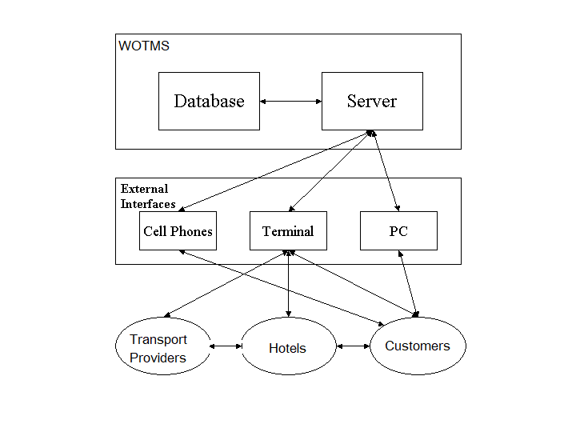

Functions of System Components:

Database:
• Stores data
• Creates reports
• Provides access to data
• Updates information

Server:
• Provides access to the database
• Authenticates users
• Processes reservations
• Performs backups
• Produces reports

External Interfaces:

Terminal
• Users use terminals to access the server
• Customer use terminals to reserve the booking and to get information about the available seats on particular packages and track transaction id.
• Administration use terminals to approve the order change rights and get reports generated by the database software.

Personal Computers
• Customers may use personal computers to obtain a remote access to the server and the reservation database via the Internet.

Cell Phones
• Serve as a medium of accessing the server and the reservation database.
• Customers may use cell phones and the latest telecommunication technologies to access the server and the reservation database via Internet, or they may use cell phones to call travel agents to inquire about more information.

Computer Hardware and Peripheral Equipment to be used:
• 6 workstations, which include CPUs, monitors, keyboards, and mice
• Printers
• Network
• Terminals
• Cell phones to test connection to the server via remote access

2.2 Product Functions
This section provides a summary of the functions that the software will perform.
2.2.1 Function Relationships
Figure 2.2 to 2.6 depict the relationships among the functions to be implemented by the system.

Figure 2.2 WOTMS General Function Relationship/Higher Level Usecase Diagram
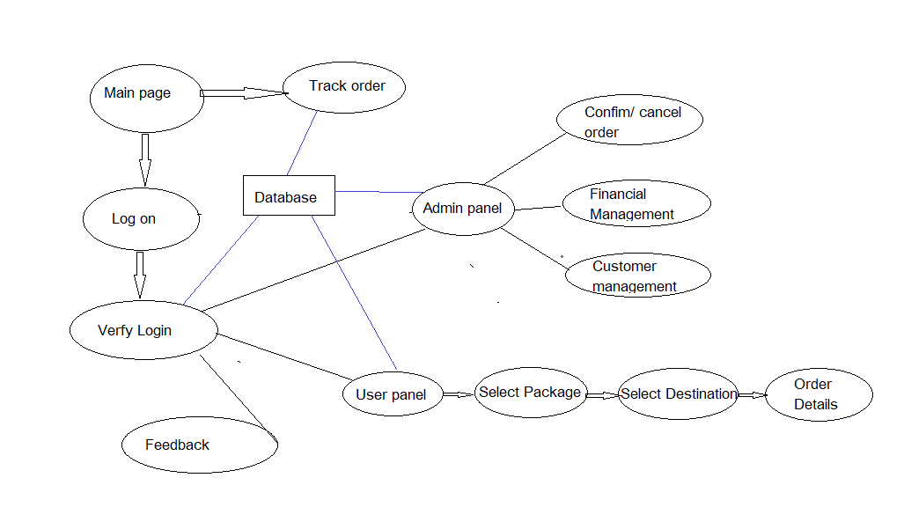

2.2.2 Function Descriptions (Functional Requirement Listings)

2.2.2.1 Log In Function

Description: This function ensures that only authorized users gain access to the Reservation databases. An authorized user is a user who has an account on the system. Users include passengers, train officials, and WorldSky ozone officials. The user must type a valid username and password to gain access.

a. Module 1: Login Authentication (Common for all members)
b. Module 2: Graphic user interface designing and admin panel development
c. Module 3: Database designing
d. Module 4: Customer side development
e. Module 5: Admin panel improvement and design
f. Module 6: Order verification and feedback
g. Module 7: Admin panel accessibility

Member 1: Login + Module 2
- Demonstration of Create activity on Module 2
Admin Side user interface and development.
- Demonstration of Review activity on Module 2
Admin side User interface.
- Demonstration of Update activity on Module 2
If any new packages and customer information is updated it will be updated automatically.
- Demonstration of Delete activity on Module 2
If any customer wants to delete selected package it’s applicable and deleted.
- Demonstration of Search activity on Module 2
Search and track the orders and packages.

Member 2: Login + Module 3
- Demonstration of Create activity on Module 3
Create database and regarding tables and create relation between them. According to the features.
- Demonstration of Review activity on Module 3
The stored data will be reviewed and checked
- Demonstration of Update activity on Module 3
The Data can be updated/ edit through different sql queries
- Demonstration of Delete activity on Module 3
Data can be searched by using queries
- Demonstration of Search activity on Module 3
Data can be searched by using queries

Member 3: Login + Module 4
- Demonstration of Create activity on Module 4
User/ customers can create customize applied by Graphical
- Demonstration of Review activity on Module 4
Can review the details of packages
- Demonstration of Update activity on Module 4
Can update data stored table if required.
- Demonstration of Delete activity on Module 4
Customer can delete selected package
- Demonstration of Search activity on Module 4
Search for different destination.

Member 4: Login + Module 5
- Demonstration of Create activity on Module 5
Admin can login and create packages and destination.
- Demonstration of Review activity on Module 5
Admin can review packages and customer information
- Demonstration of Update activity on Module 5
Admin can update all the details
- Demonstration of Delete activity on Module 5
Admin can delete necessary customer details upon non payment
- Demonstration of Search activity on Module 5
Admin can search the customer details.

Member 5: Login + Module 6
- Demonstration of Create activity on Module 6
Customer can give feedback.
- Demonstration of Review activity on Module 6
Can view the order confirmation.
- Demonstration of Update activity on Module 6
Change the state of order after payment of customer.
- Demonstration of Delete activity on Module 6
Can delete the users login.
- Demonstration of Search activity on Module 6
View the details of transactions.

Member 6: Login + Module 7
- Demonstration of Create activity on Module 7
Admin can view the feedback.
- Demonstration of Review activity on Module 7
Can view the order confirmation.
- Demonstration of Update activity on Module 7
Change the state of order after payment of customer.
- Demonstration of Delete activity on Module 7
Can update the users authority.
- Demonstration of Search activity on Module 7
View the details of transactions.

2.3 User Characteristics
The main users of the system will be the customers buying travel packages, the travel agents that process reservations for passengers, and the administration that access the reports generated by the system. The users are not required to have knowledge in the computer field. The graphical interface provides an easy way of using the WOTMS system with minimum of training.

2.4 General Constraints
The constraints for the project are:
- The functional prototype should be available after 30 days upon the arrival of the management team to WorldSky ozone travels. This may prove to be a serious time constraint on the development of a successful prototype.
- Team members are restricted from bringing their own equipment, and insufficient equipment supply may hinder project development.
- Team members are restricted to bringing only the analysts of the team to company environment. This might affect the project development if more people are needed or the required skills are not available.
2.5 Assumptions and Dependencies or Business Logic
The assumptions for the project are:
- Reservation can be made up to10 days before a particular trip.
- Seats will assign after payment.
- Those customer not pay booking will be cancel.
- The expected reservations during test period may amount to approximately 25,000 per day. This volume varies by hour, day, and season. Network connection will always remain established.

3. Specific Requirements

This section of the SRS contains design requirements for the WorldSky Ozone Tourism management system.

3.1 Functional Requirements

3.1.1 Module 1 complete Log In Function

- Description: This function ensures that only authorized users gain access to the databases. An authorized user is a user who has an account on the system. Users include customers and WOTMS officials. The user must type a valid username and password to gain access.

- Usage Scenario/ Use case Description/ Specification:

Description | Allows access to online WOTMS
Inputs | Username, password
Source | - User inputs username and password  - Press Login Button

Alternate case
Outputs | Successful login; unsuccessful login
Destination | Dashboard and Customer panel
Precondition | Authorized User
Post Condition | No change to Passenger Accounts Database
Side Effects | Failures and successful logins are sent to Reservation Database

    - Module 2 complete CRUD Graphic user interface designing and admin panel development.
- Description: This function allows the admin to [make | drop | view | update] in dashboard panel for a particular package on a particular date for a certain number of customers. With GUI.

- Usage Scenario/ Use case Description/ Specification:

Admin Side user interface and development. If any new packages and customer information is updated it will be updated automatically. If any customer wants to delete selected package it’s applicable and deleted and shown to admin. Search and track the orders and packages as well as admin manage orders and users in dashboard.

    - Module 3 complete CRUD Database design and functionality

Description: A complete database design for implementation in functions inside the system including ER diagrams.

Usage Scenario/ Use case Description/ Specification:
ER Designing and development of database including all tables necessary shown in class diagram.

    - Module 4 complete CRUD Customer side development
Description: This function allows the customer to [make | drop | view | update] in main side panel for selection of package on a particular transaction.

Usage Scenario/ Use case Description/ Specification:
It includes packages with info, selection of destination and transaction.

    - Module 5 complete CRUD Admin panel improvement and design
Description: Module regarding to expense management and profit view
for admin side.

Usage Scenario/ Use case Description/ Specification:
Complete accessibility from database from admin panel

    - Module 6 complete CRUD Order verification and feedback
Description: This module provide integration to database

Usage Scenario/ Use case Description/ Specification:
Direct access from dashboard using database.

    - Module 7 complete CRUD Admin side specification
Description: This module allow to admin and user to manage the order
tracking feature and feedback option which can access by admin and
customer.

Usage Scenario/ Use case Description/ Specification:
These module manage from admin dashboard.

Diagrams

- Use case Diagram:

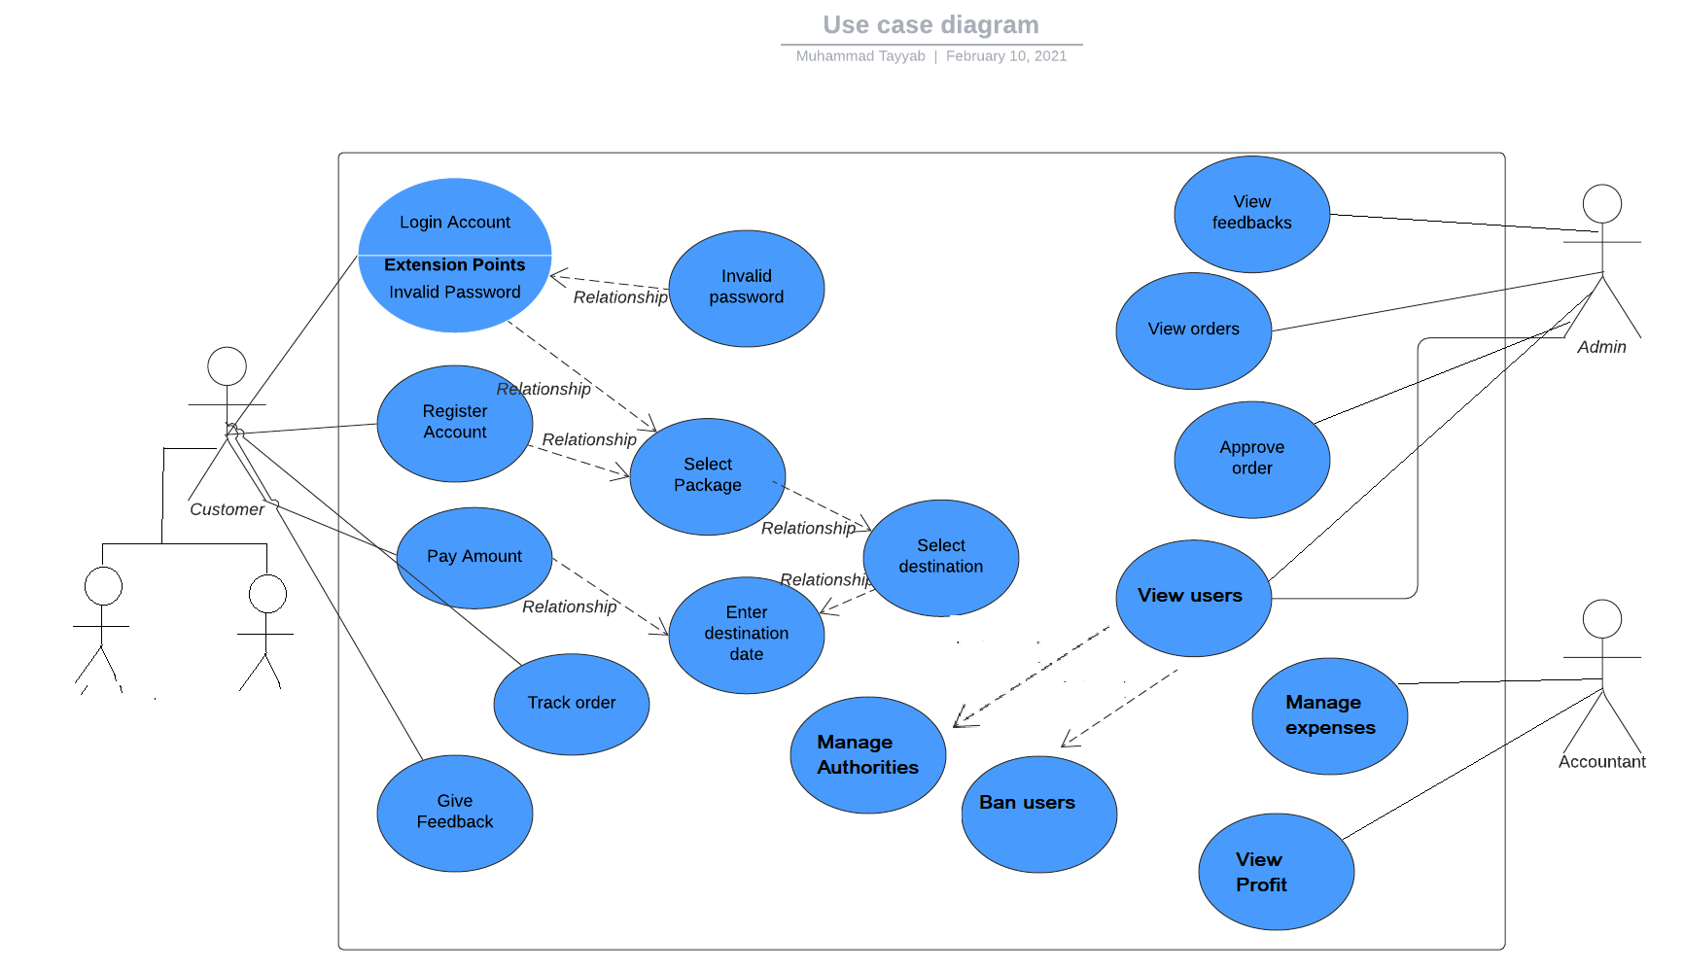

- Use case Realization:

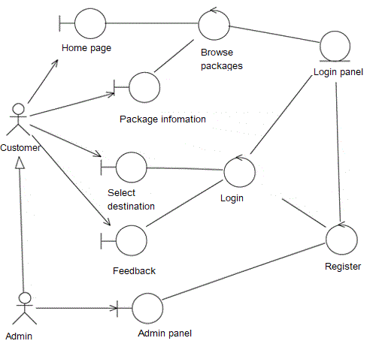

- Flow of Event or Data Flow Diagram:

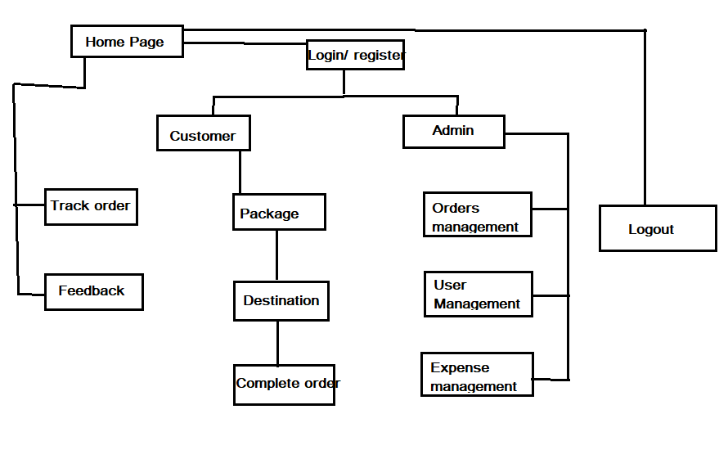

- Sequence Diagram:

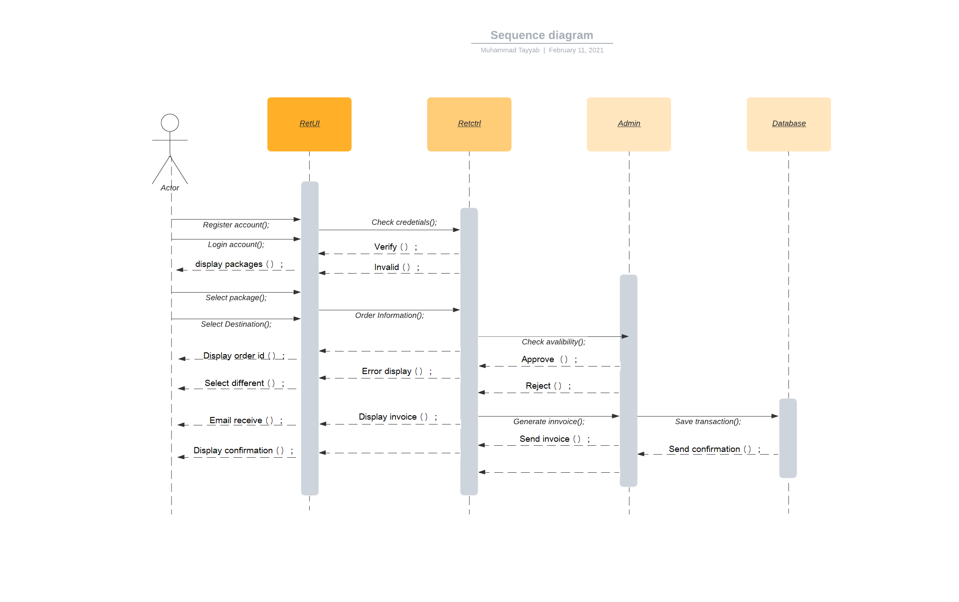

- Collaboration Diagram:

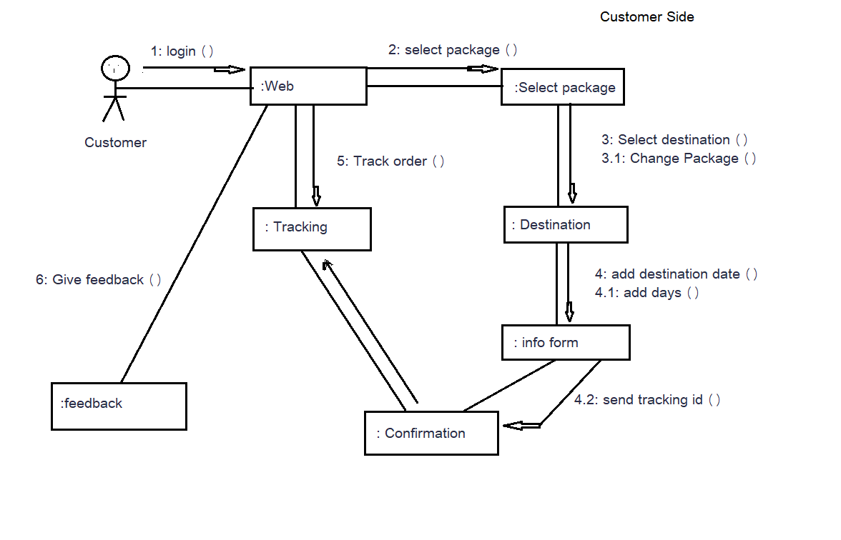

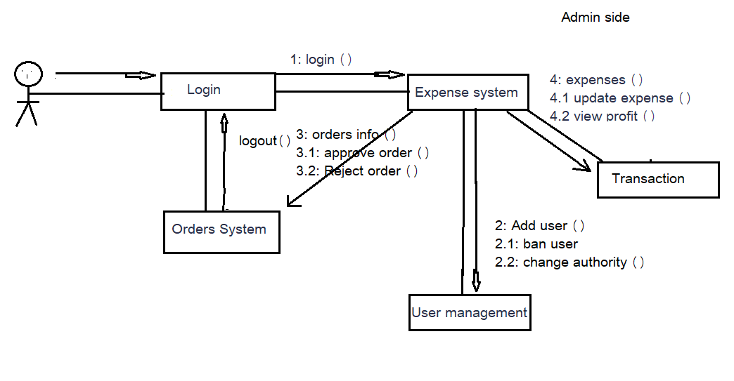

- Activity Diagram:

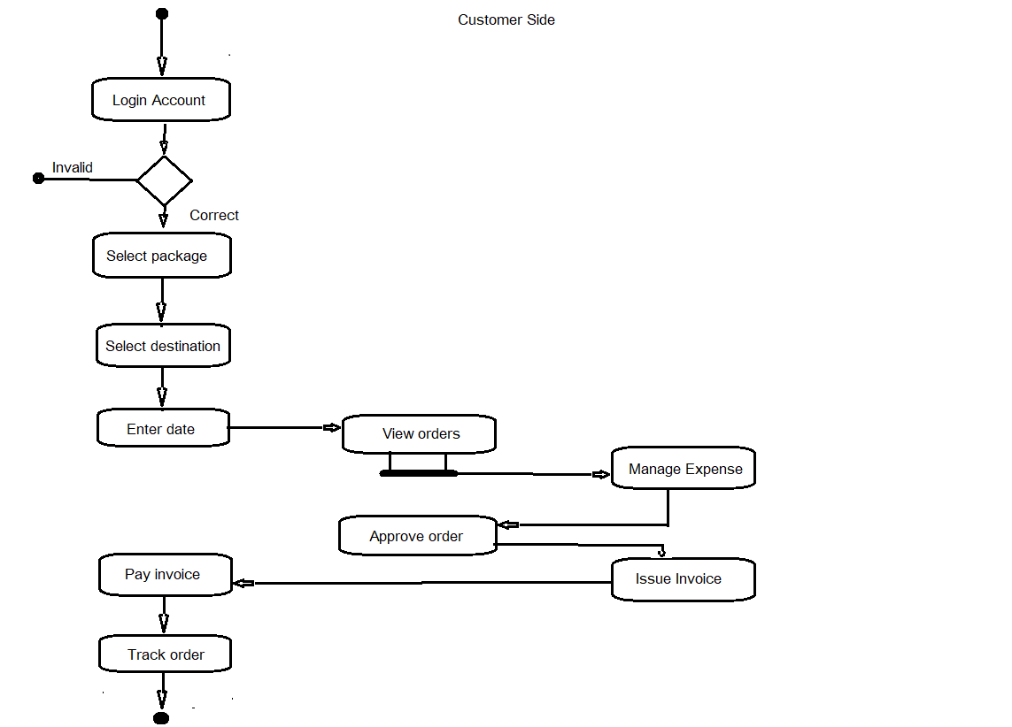

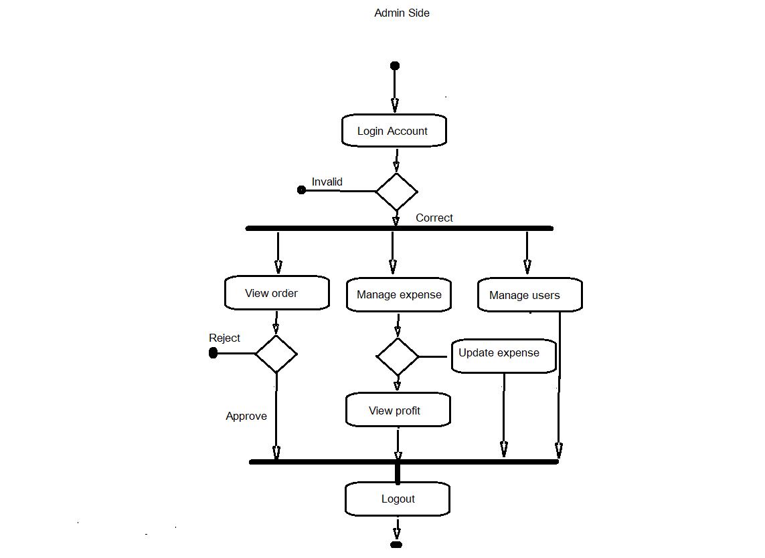

- Class Diagram:

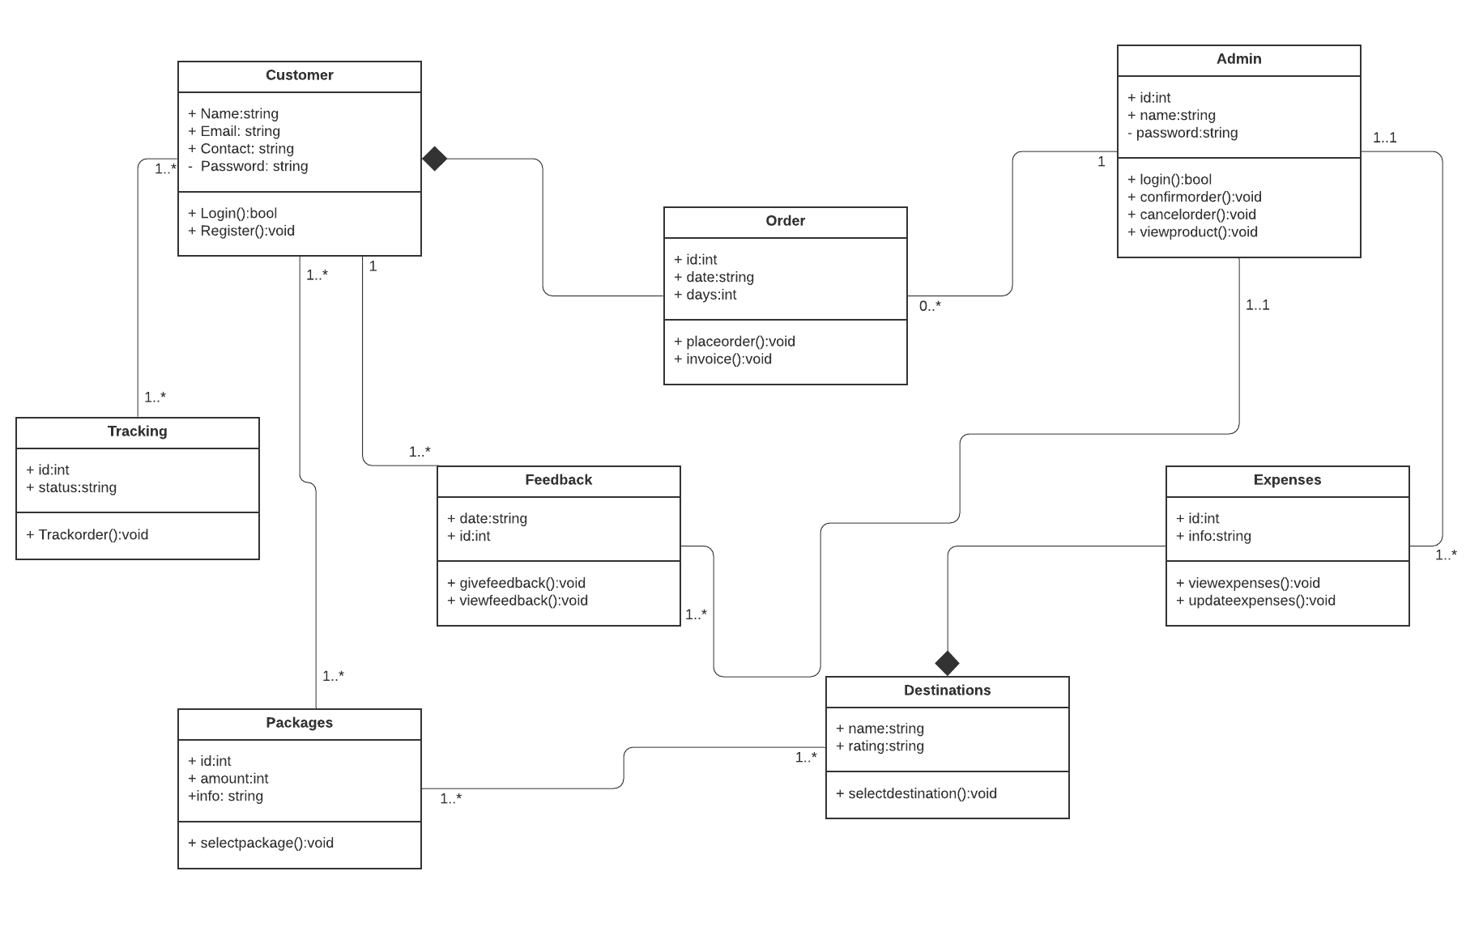

- State Chart Diagram:

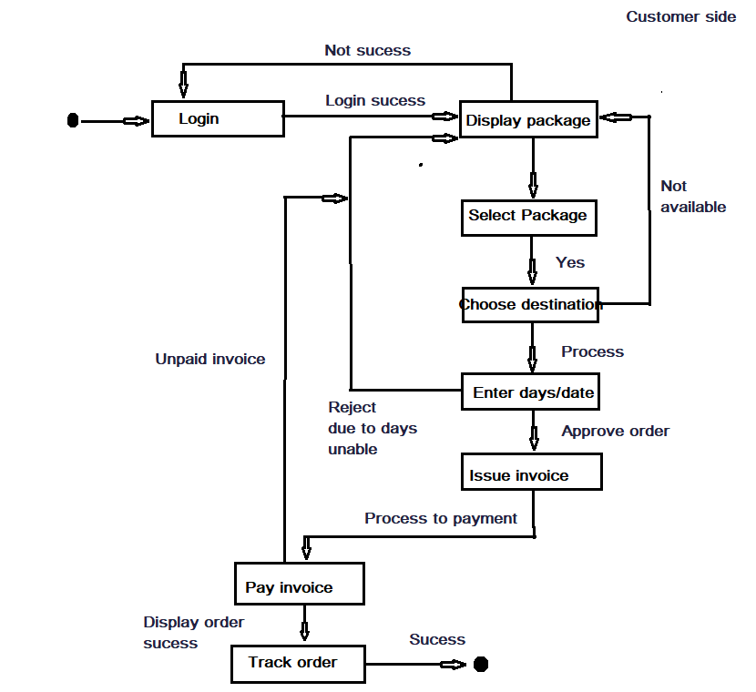

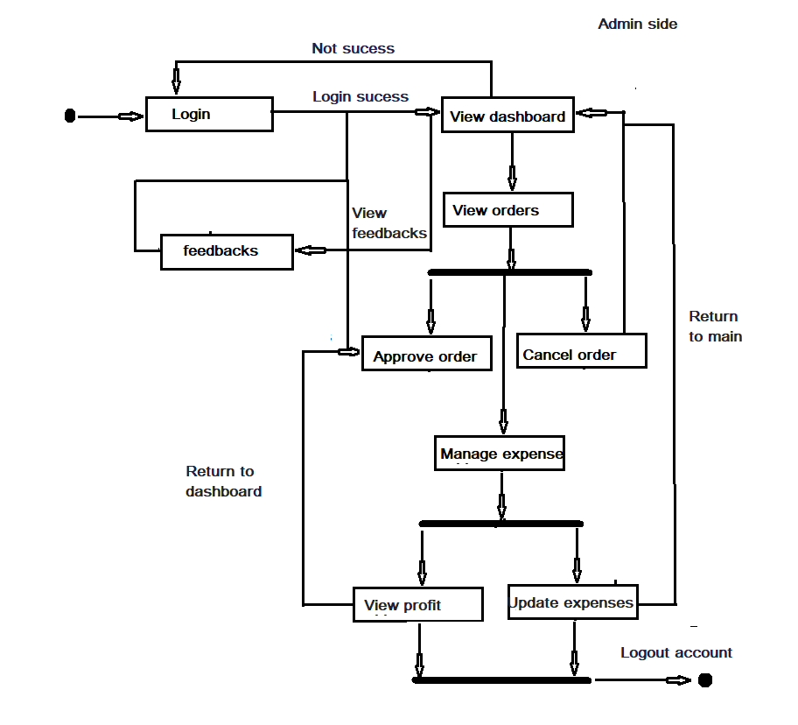
3.2. External Interface Requirements
3.2.1 User Interfaces
The user interfaces are divided into two major components. One part includes the user accessing the system using a login. The other portion involves accessing the system through a remote site or at a particular location specifically designed to access the system. For instance, the admin.
The diagrams and explanations below demonstrate the major transition from one user interface to another. This is a brief description. However, a more detailed demonstration is done in the prototype. The purpose of this interaction is to illustrate the overall view of the WOTMS
Packages
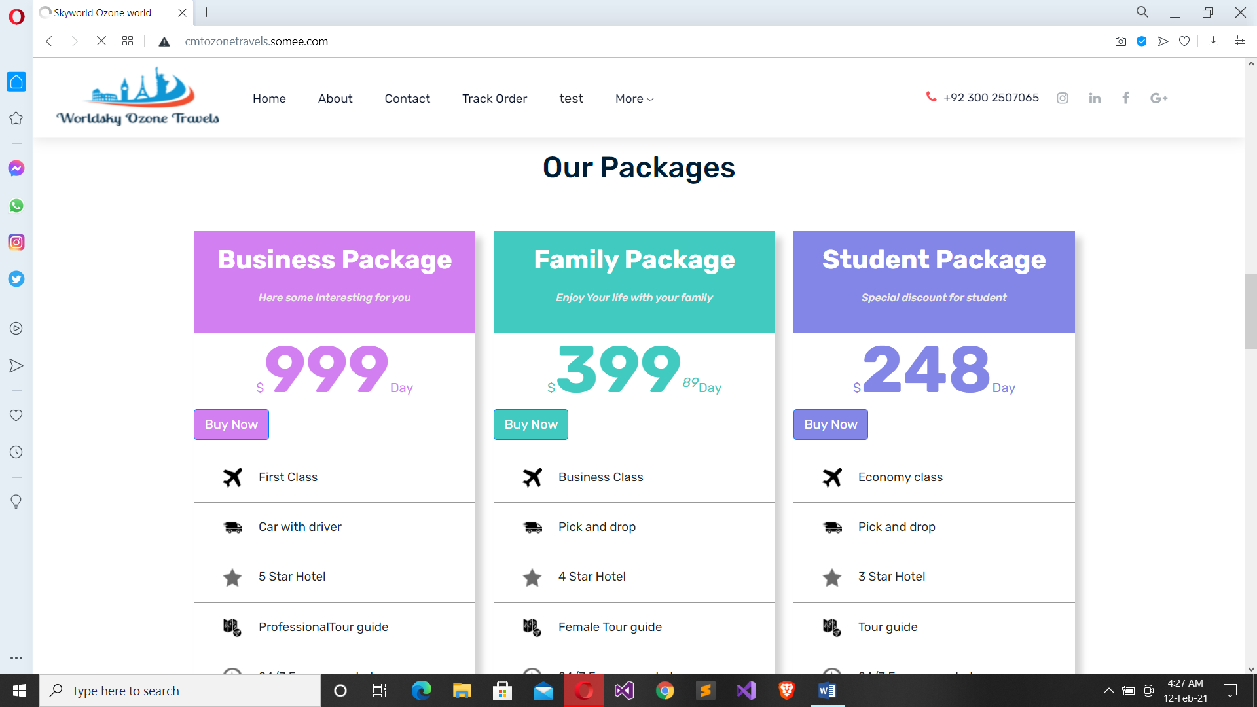

Destinations
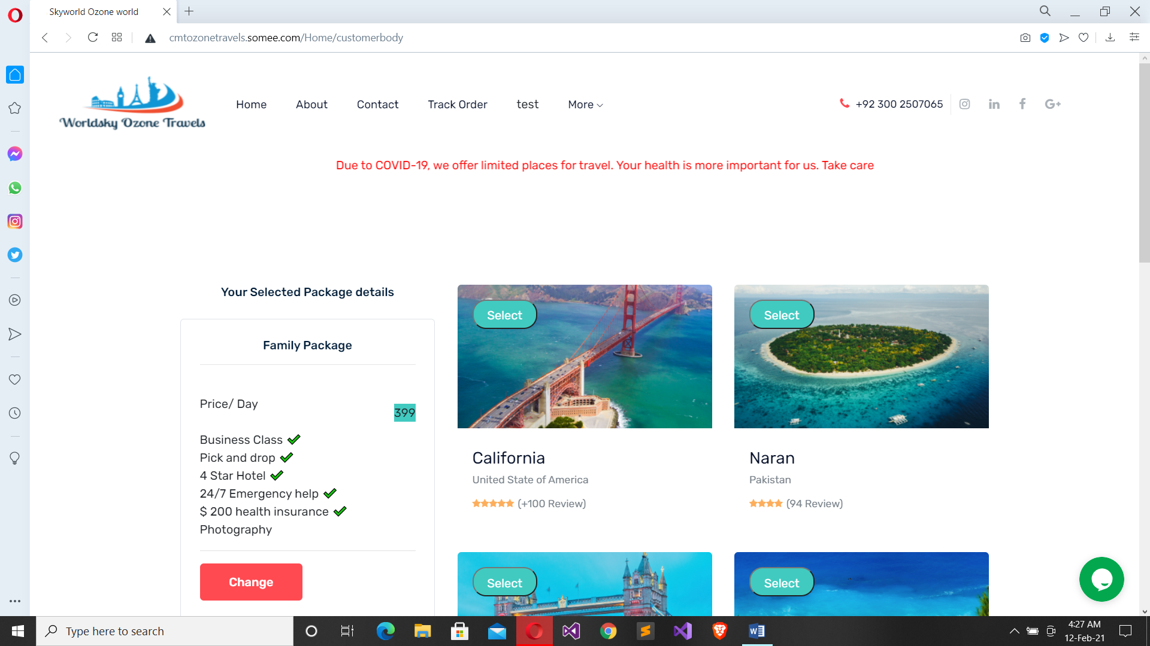

Transaction
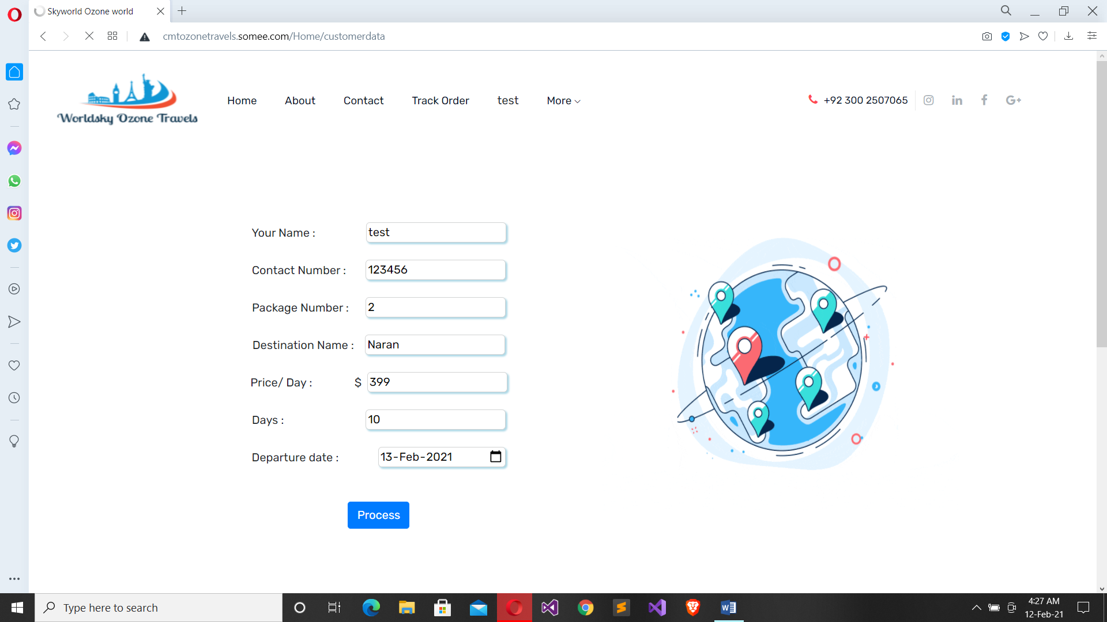

Order confirmation
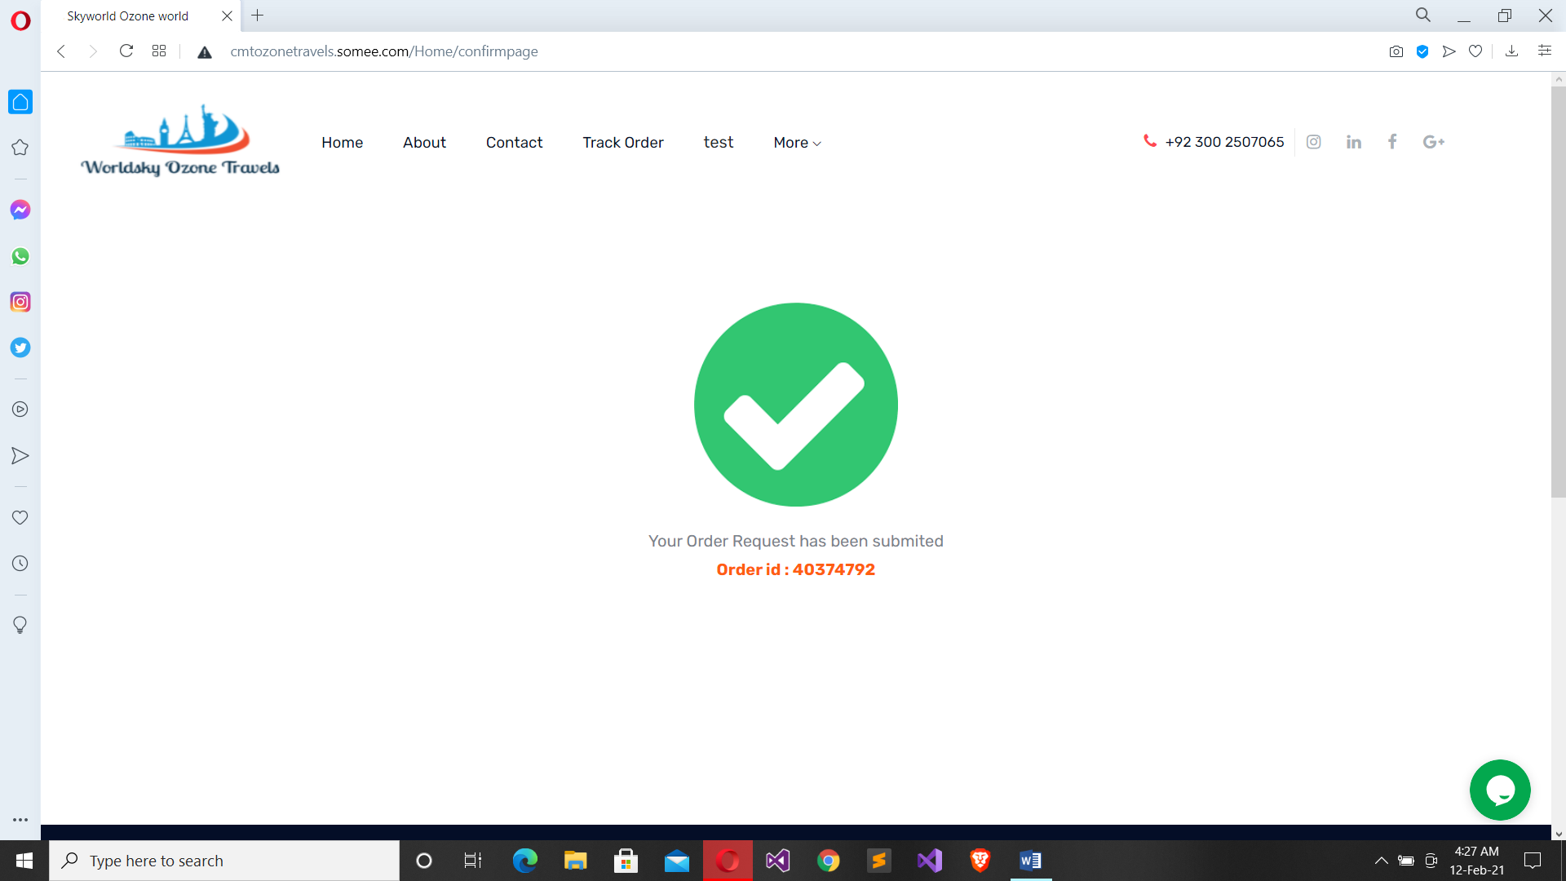

Feedback
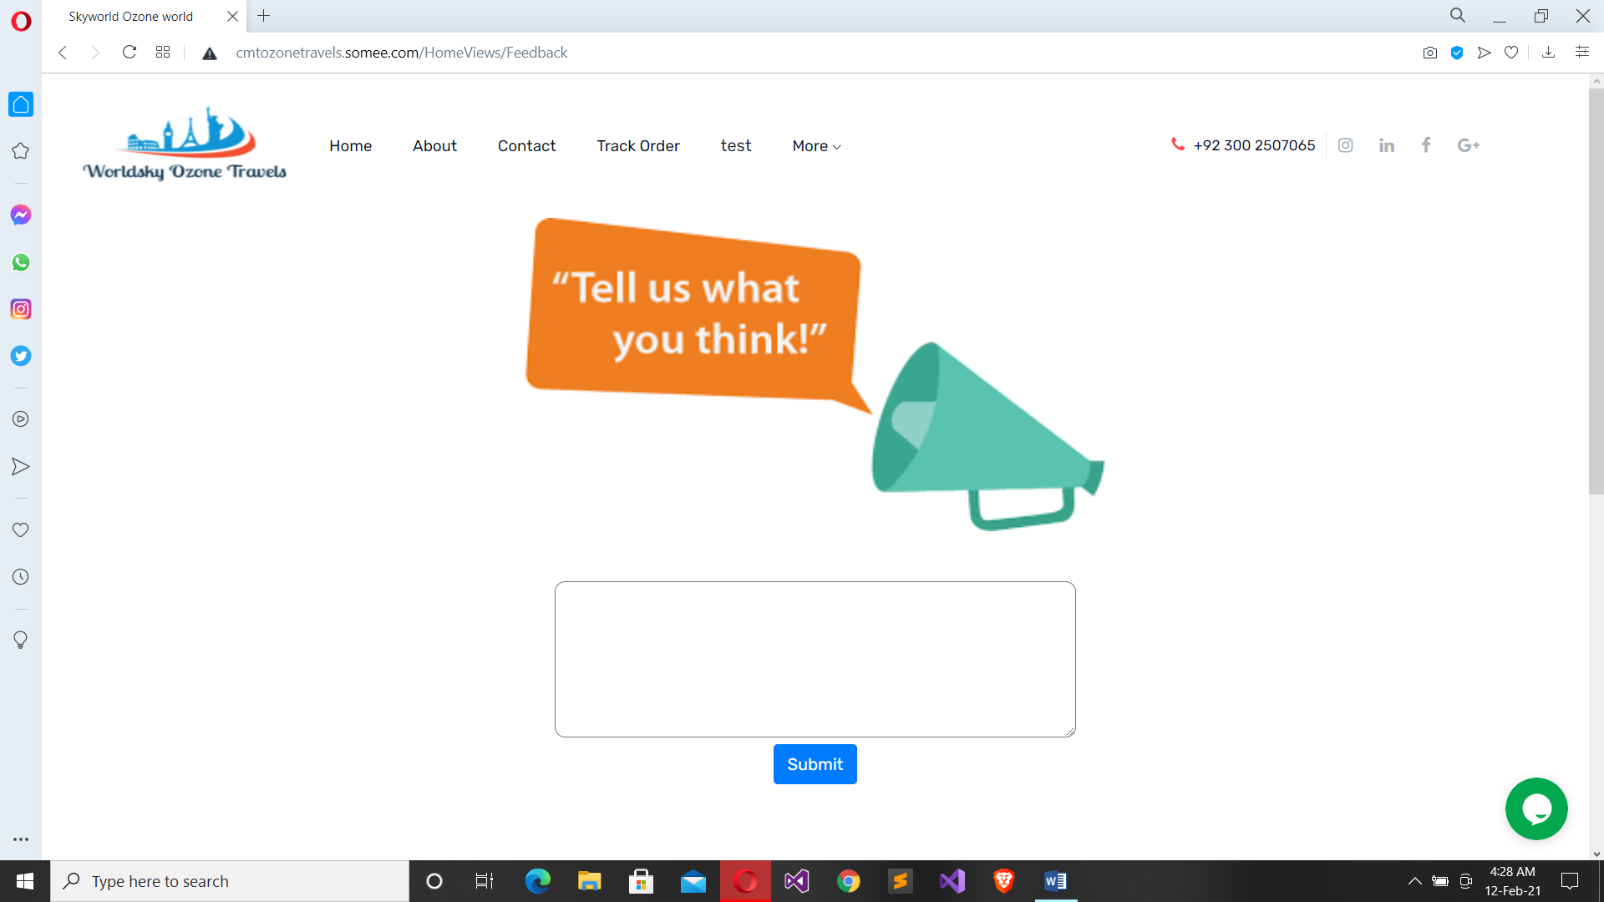

Sign in
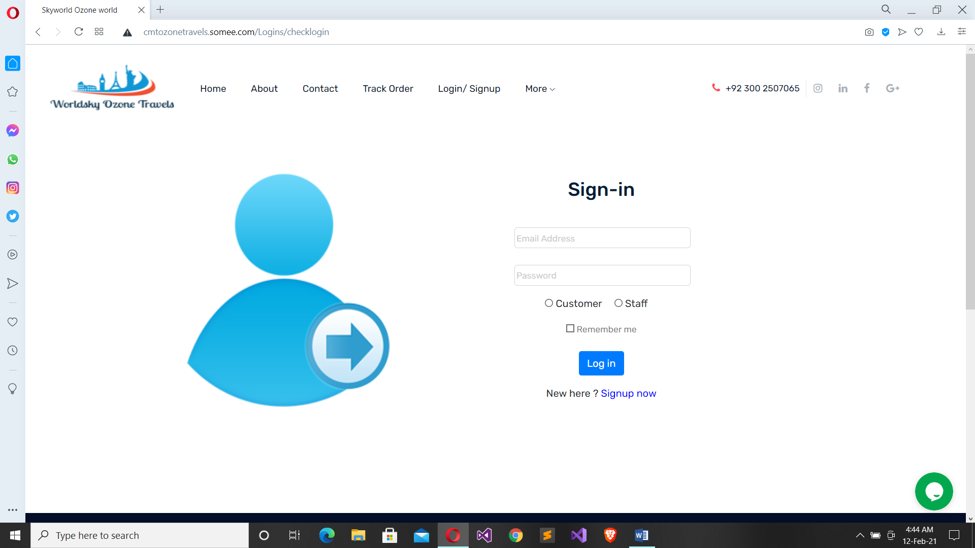

Dashboard

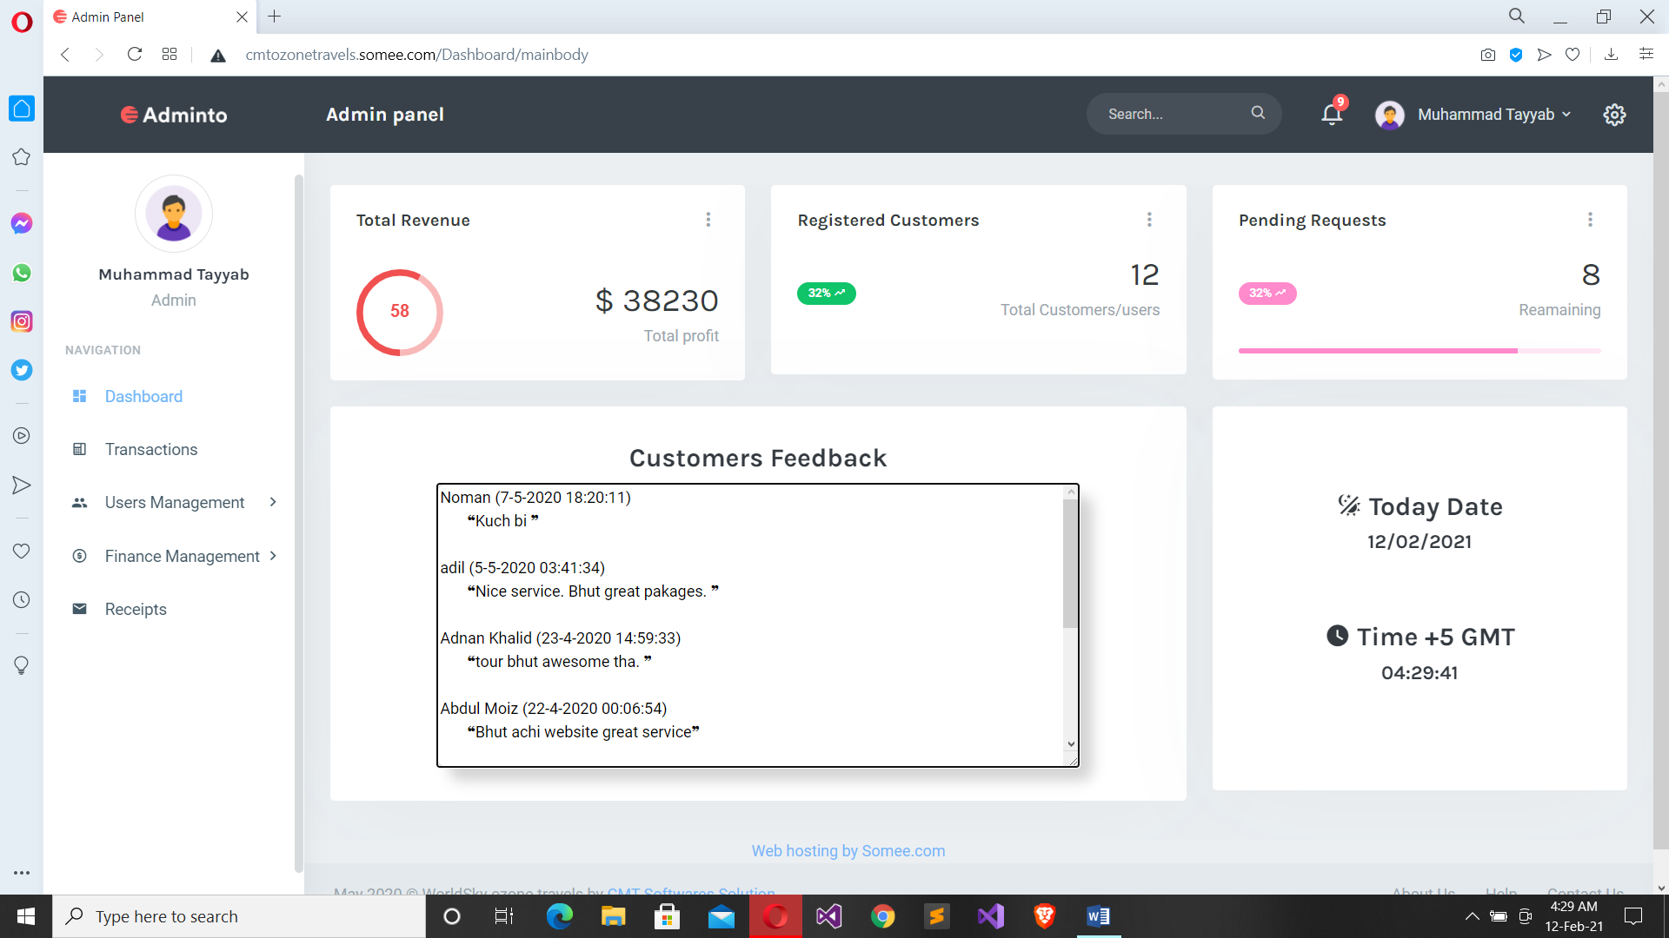

3.2.2 Hardware Interfaces
The WOTMS includes two major hardware components: cellular phones and regular PC's. The cell phones require WAP (wireless application protocol) network protocol, which is already programmed in the latest phones.
The second component involves the regular PC’s, which communicate with the server. The server then communicates with the database. The protocol involved between the PC's and the server is the HTTP protocol, which allows communication between the PC's and the Server. The remote PC's, such as someone accessing the WOTMS from home using the Internet, are able access the information through the CGI. The requests come in through the HTTP protocol, and using an ODBC the database results are returned and processed using Perl to give an HTML web page. The format of the output is displayed as web pages.

3.2.3 Software Interfaces

- Visual Studio 2013 / 2019
- SQL server management studio
- .net framework

3.3 Performance Requirements

3.3.3 Host Requirements

 | Type of Host or  Equipment | Numbers and  Locations
Host A | PC | 6
Host B | Database Server | Washington
Host C | Application Server | Washington

3.4.1 Standards Compliance
There are no design constraints that can be imposed by other standards limitations.

3.4.2 Software Limitations
• must be able to run Internet Explorer or Netscape Communicator web browsers to access the system.
• must have cell-phone web based capability to access the system from a mobile phone.

3.4.3 Hardware Limitations
• Input/Output: One or two-button mouse, keyboard, cell-phone, or touch screen required.
• Network card required at thin-client terminals to make communication with server possible.

3.5 Quality Characteristics
There are a number of quality characteristics that apply to the ARRS software system.

3.5.1 Portability
The WOTMS system will be developed using HTML and .net so that it can be accessed from any type of system using just a regular web browser. It will also be available to users that have web access on their cellular phones. The system will be tested on all types of hardware before being released to ensure that is it compliant with this requirement.

3.5.2 Reliability

The system should be capable of processing a given number of reservations within a give time frame with no errors and the system should be available and operational all the time. During the development of the prototype for the 3 cities, the system will be tested in its actual environment to ensure that it can handle the load of reservations that occur during a regular workday.

3.5.3 Usability
The WOTMS system will be developed so that it is an easy to use system that requires the least amount of user input possible. Every input will be validated. The user should only have general computer use knowledge. Error messages will be displayed if the user enters an invalid value or tries to access a function without the required permissions. An easy and well-structured user manual will be provided to the WOT and the system will include descriptive help for all operations allowed.
3.5.4 Correctness
The ARRS system will be considered correct when the WOT approves the prototype presented and agrees that all the functions they require are implemented as stated in the Software Requirements Specification.
3.5.5 Flexibility
The WOTMS system should be developed in such a way that it is easily customizable. If new functions are required by WOT, there will be little effort required to update the system to support new cities or new transactions.
3.5.6 Security

The WOTMS system should not compromise the customer information at any time. The user information will never be sold to other parties and will be kept secure at all times. Users will be authenticated to ensure that no unauthorized users gain access to private information.

3.5.7 Maintainability
The WOTMS source code will be kept well structure and documented so that it is easier to maintain and extend the system. All changes to the system shall be documented.

3.6.2 Operations
The normal operations required by the user can be viewed as the following:
User-initiated Operations:
These operations include the login operation, which is initiated by the users. Also, the process of becoming a new user is in this category. Building, changing, and viewing itineraries, as well as paying for the itinerary are all initiated by the users. The user initiates the report generation activity, as well as changing train schedules.
Interactive Operations and Unattended Operations:
The users initiate all the operations mentioned above, and almost all of them are somehow interactive. Displaying the train schedule is non-interactive. The report display is a non-interactive operation, although selecting the desired reports will require user input.
Data Processing Support Functions:
The user account data is used to create new accounts, as well as to validate user id's during login functions. For building itineraries, user input, user account data, and train schedule data are used, and processed. User data along with final results of user interaction (whether the user purchased a trip, number of tickets bought, etc.) are collected, and used for report generation purposes. Administrative users' inputs are collected in order to modify and present schedules.
Backup and Recovery Operations:
Both databases used (passenger account database and reservations database) are production databases. The main operation used for the backup and recovery function of sql database.
3.6.3 Site Adaptation Requirements
There are no site adaptation requirements for this project.

4. Supporting Information.
There is no supporting information required for this project.

